**Motive:**

**How a web application can connect to an AWS RDS instance and use it to write its data to it?**

**How to visualize the data in real that the website is writing to the RDS DB Instance?**

**Drupal CMS**: Is a Content Management System (CMS), used for blogs, websites etc. It is a powerful, flexible, and secure platform to develop websites. Used by:  [Pinterest](https://w3techs.com/sites/info/pinterest.com) to [the NBA](https://w3techs.com/sites/info/nba.com) and [League of Legends](https://w3techs.com/sites/info/leagueoflegends.com).

Drupal site will store its data to an AWS RDS instance (mysql).

**Steps:**

1. Create the RDS instance and configure security group to allow the connections.
2. Create an EC2 instance to configure drupal for web application and mysql to interact with the RDS instance.
3. Configure RDS connection with Drupal from the UI.
4. Write some test blogs to generate data from the site.
5. Use mysql to visualize the written data.

**Step 1:** [**https://youtu.be/WaZslRCQqx4**](https://youtu.be/WaZslRCQqx4)

**Step 2: Use Amazon Linux 2023 AMI**

**Commands to configure mysql:**

sudo dnf install -y mariadb105

export MYSQL_HOST=<RDS-endpoint>

mysql --user=<master-user> --password database-name

**Commands to create a Database user to access the database. This user will be used by the application to connect to the database.**

CREATE USER 'drupal' IDENTIFIED BY 'drupal';

GRANT ALL PRIVILEGES ON drupaldb.* TO drupal; FLUSH PRIVILEGES;

Exit

**Commands to configure web application (Drupal, php, apache packages):**

sudo dnf install -y httpd

sudo vim /etc/httpd/conf/httpd.conf

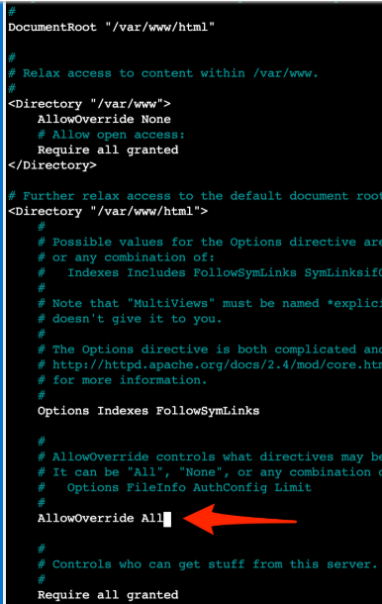 

sudo service httpd start

sudo dnf install -y php8.2 php-dom php-gd php-simplexml php-xml php-opcache php-mbstring

sudo dnf install -y php-mysqlnd

sudo wget https://ftp.drupal.org/files/projects/drupal-10.2.6.tar.gz

sudo mv drupal-10.2.6.tar.gz tar.gz

sudo tar -xzf tar.gz

sudo mv drupal-* drupal

cd drupal

sudo rsync -avz . /var/www/html

sudo chown -R apache:apache /var/www/html

sudo service httpd restart

**Step 3: Configure drupal web site from the UI**

**Step 4: Write test blogs to generate relational data in the form of tables (rows and columns)**

**Step 5: Visualize data using the following mysql commands:**

select * from node_field_data;

select * from users_field_data;

select type from node_field_data;

select title from node_field_data;